DBMS Record

Set – 1

Set – 2

Create the following tables and execute the queries given below.

SAILORS  
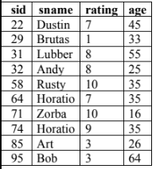

BOATS

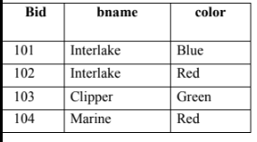

RESERVES

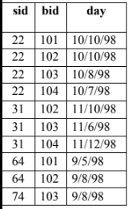

SQL> create table sailors (sid int not null primary key, sname varchar(25), rating number(2), age number)

Table created.

SQL> insert into sailors values(22,'DUSTIN',7,45);

1 row created.

SQL> insert into sailors values(29,'Brutus',1,33);

1 row created.

SQL> insert into sailors values(31,'Lubber',8,55);

1 row created.

SQL> insert into sailors values(32,'Andy',8,25);

1 row created.

SQL> insert into sailors values(58,'Rusty',10,35);

1 row created.

SQL> insert into sailors values(64,'Horatio',7,35);

1 row created.

SQL> insert into sailors values(71,'Zorba',10,16);

1 row created.

SQL> insert into sailors values(74,'Horatio',9,35);

1 row created.

SQL> insert into sailors values(85,'Art',3,26);

1 row created.

SQL> insert into sailors values(95,'Bob',3,64);

1 row created.

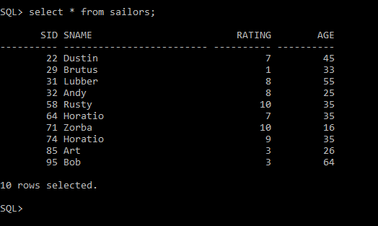

SQL> create table boats (Bid int not null primary key, bname varchar(25), color varchar(20));

Table created.

SQL> insert into boats values(101,'Interlake','Blue');

1 row created.

SQL> insert into boats values(102,'Interlake','Red');

1 row created.

SQL> insert into boats values(103,'Clipper','Green');

1 row created.

SQL> insert into boats values(104,'Marine','Red');

1 row created.

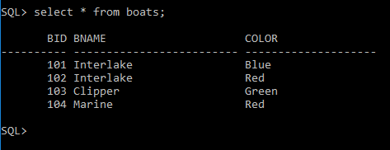

SQL> create table reserves(sid int references sailors(sid),bid int references boats(bid),day date);

Table created.

SQL> insert into reserves values(22,101,'10/oct/98');

1 row created.

SQL> insert into reserves values(22,102,'10/oct/98');

1 row created.

SQL> insert into reserves values(22,103,'10/Aug/98');

1 row created.

SQL> insert into reserves values(22,104,'10/Jul/98');

1 row created.

SQL> insert into reserves values(31,102,'11/Oct/98');

1 row created.

SQL> insert into reserves values(31,103,'11/Jun/98');

1 row created.

SQL> insert into reserves values(31,104,'11/Dec/98');

1 row created.

SQL> insert into reserves values(64,101,'09/May/98');

1 row created.

SQL> insert into reserves values(64,102,'09/Aug/98');

1 row created.

SQL> insert into reserves values(74,103,'09/Aug/98');

1. row created.

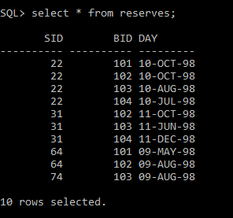

1. Find the names and ages of all sailors

SQL> select sname,age from sailors;

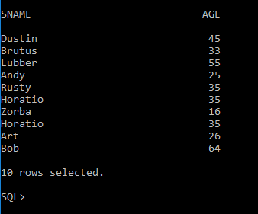

1. Find all information of sailors who have reserved boat number 101.

SQL> select * from sailors,reserves where sailors.sid=reserves.sid and reserves.bid=101;

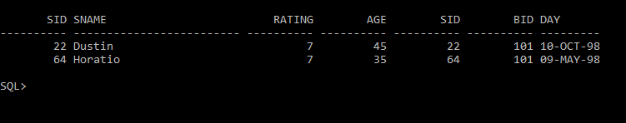

1. Find all sailors with rating above 7.

SQL> select * from sailors where rating>7;

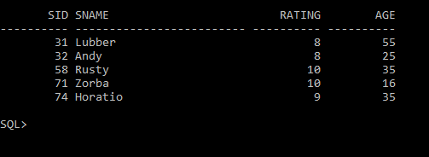

1. Find the names of sailors who have reserved boat no 103.

SQL> select sailors.sname from sailors,reserves where sailors.sid=reserves.sid and reserves.bid=103;

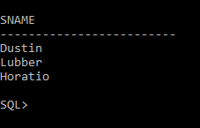

1. Find the names of sailors who have reserved a red boat, and list in the order of age.

SQL> select distinct s.sname,s.age from sailors s,reserves r,boats b where s.sid=r.sid and r.bid=b.bid and b.color='Red' order by s.age;

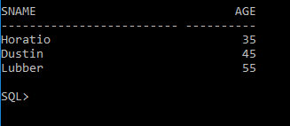

1. Find the names of sailors who have reserved either a red or green boat.

SQL> select distinct s.sname from sailors s,reserves r,boats b where s.sid=r.sid and r.bid=b.bid and (b.color='Red' or b.color='Green');

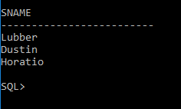

1. Find the colors of boats reserved by “Lubber”.

SQL> select distinct b.color from sailors s,reserves r,boats b where s.sid=r.sid and r.bid=b.bid and s.sname='Lubber';

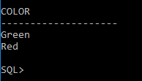

1. Find the names of sailors who have reserved both red and green boats.

SQL> select s.sname from SAILORS s,BOATS b,RESERVES r where s.sid=r.sid and r.Bid=b.Bid and b.color='Red' intersect select s.sname from SAILORS s,BOATS b,RESERVES r WHERE s.sid=r.sid and r.Bid=b.Bid and b.color='Green';

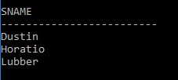

1. Find the names of sailors who have reserved at least one boat

SQL> SELECT DISTINCT s.sname FROM SAILORS s, RESERVES r WHERE s.sid=r.sid;

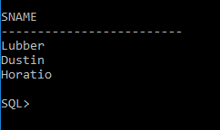

1. Find the ids and names of sailors who have reserved two different boats on the same day.

SQL> SELECT DISTINCT s.sid,s.sname FROM SAILORS s,RESERVES r1,RESERVES r2 WHERE s.sid=r1.sid AND s.sid=r2.sid AND r1.day=r2.day AND r1.Bid<>r2.Bid;

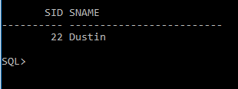

1. Find the name and the age of the youngest sailor.

SQL> select s.sname,s.age from sailors s where s.age<=all(select age from sailors);

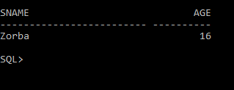

1. Find the names and ratings of a sailor whose rating is better than some sailor called Horatio.

SQL> select s.sname,s.rating from sailors s where s.rating>any(select s2.rating from sailors s2 where s2.sname='Horatio');

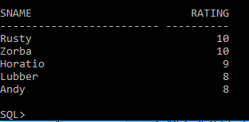

1. Find the names of sailors who have reserved all boats.

SQL> select s.sname from sailors s where NOT EXISTS ( select b.bid from boats b where NOT EXISTS ( select r.bid from reserves r where r.bid = b.bid and r.sid = s.sid) );

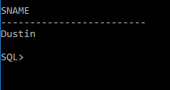

1. Count the number of different sailor names.

SQL> select count(distinct s.sname)from sailors s;

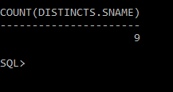

1. Calculate the average age of all sailors.

SQL> SELECT AVG(s.age) FROM SAILORS S;

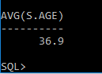

1. Find the average age of sailors for each rating level.

SQL> select s.rating,avg(s.age)as avg_age from SAILORS s group by s.rating;

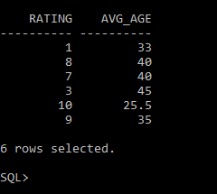

1. Find the average age of sailors for each rating level that has at least two sailors.

SQL> select s.rating,avg(s.age)as avg_age from SAILORS s group by s.rating having count(*)>1;

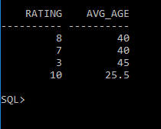

Set – 3

Consider the following schema for OrderDatabase:

**SALESMAN** (Salesman_id, Name, City, Commission)

**CUSTOMER** (Customer_id, Cust_Name, City, Grade,Salesman_id)

**ORDERS** (Ord_No, Purchase_Amt, Ord_Date, Customer_id,Salesman_id)

Write SQL queries to the above mentioned tables.

SQL>